Monday 27th June 2022
Dear Pupil,
Welcome to Year 4!
I am really looking forward to being your teacher next year. We will learn lots of intersting things together! Helping in our class will be Miss Walker and Mrs Mulholland.
Some of the things that we will are going to learn in literacy and numeracy include:
- Multiplication and division tables
- Lots of opportunities to read including Accelerated Reader
- Lots of fun Mental Maths Activities
You can also look forward to learning about these topics in the World Around Us:
- Animals
- World War 2
- Space
To make sure that we have a great year I need you to ensure that you have the following school supplies:
- Pritt Stick (put your name on it). You will need a new one when this one is used.
- 3 sharp pencils, sharpener, colouring pencils/crayons, rubber
- Plastic ruler (30 cm)
- Colouring book/sketch book/word search book
- Box of Tissues
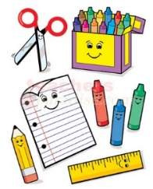
Make sure that you have a school bag that you can carry yourself but will also hold an A4 homework folder and your library book. If you are bringing your break or lunch to school, you should have it in a lunch bag or lunch box.
I am looking forward to learning new things with you next year!
Kind regards,

Miss Collins
Ballyhenry Primary School

