Tuesday 28th June 2022
Dear Pupil,
Welcome to Year 1!
I am really looking forward to being your teacher next year and to learn lots of new things with you. We enjoy singing songs, reading stories and playing together. We especially love to play outdoors on our playpark. I will be teaching you Monday to Thursday and Mrs Murray will be your teacher on Fridays. Helping in our classroom will be Mrs Brown and Mrs McGimpsey.
You can look forward to learning about these topics in the World Around Us:
- All about me
- Toys
- Fairytales
- The Farm
- Holidays
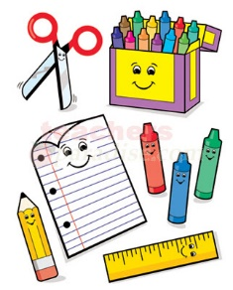
To make sure that we have a great year I need you to bring:
- Pritt Stick x3
- Colouring pencils
- Packet of tissues
- Tub of playdough
- Wellies and waterproof coat
Remember to put your name on EVERYTHING!
If you are bringing your break or lunch to school, you should have it in a lunch bag or lunch box.
I am looking forward to learning new things with you next year!
It’s going to be a lot of fun 😊

Mrs Ruddock
Ballyhenry Primary School

